

**9 - 318 - 109**

F E B R U A R Y 20, 2018

W I L L I A M R . KE R R E ME R MOL ON E Y

Vodafone: Managing Advanced Technologies and Artificial Intelligence

*There are big new winds blowing—in data analytics, automation and artificial intelligence—and they will not blow exactly in the same way across all of the organization. In my fleet some boats will gain speed, while others have smaller sails and won’t capture the same momentum. The question is whether you allow each boat to go at its own cruising speed—as we did in the beginning—or if you want to align the fleet and wrap it into a big program, as we are now trying to do. Aligning the boats is helpful for the organization, but you also risk forcing them into a linear speed that ends up being blown away by disruptors.*

— Vittorio Colao, CEO Vodafone Group

On a grey January morning in 2018, Vodafone Group CEO Vittorio Colao gazed out of his London office. Having recently launched the Digital Vodafone program to improve the customer experience and boost revenue and cost efficiency1, Colao was pleased with the quick early wins. He mused, “I don’t pretend to be particularly creative or innovative. Like every other company, we want to have the most engaging digital customer experience. We want to blend the best of our physical assets, which tend to be people or retail shops, with a digital interaction that is easy, instantaneous, but most importantly, personalized.”2

Colao highlighted the program’s main aspects, “On the customer side, we are looking to use big data to produce personalized offers for our customers—which will help us to optimize our channel mix—and to support customers more effectively and efficiently via chat bots and artificial intelligence (AI) applications. On the technology management side, we see scope for efficiency gains in our network by using real-time analytics to enable smarter network planning and predictive maintenance. On the support operations side, we aim to simplify our support activities and automate many of them through robotics.”

Colao reflected on the many ways he had to think about the move towards increasingly using data analytics, automation and artificial intelligence. He was preoccupied by three main questions, “How do I change the organization to incorporate the digital skills to improve the way the functions work? How do I incorporate machine learning and artificial intelligence that improve productivity and slash costs? What is my duty vis-à-vis broader society: what can I do to give back to society to make sure that we all create new opportunities for the next generation?”

Professor William R. Kerr and Research Associate Emer Moloney (Europe Research Center) prepared this case. It was reviewed and approved before publication by a company designate. Funding for the development of this case was provided by Harvard Business School and not by the company. The citation review for this case has not yet been completed. HBS cases are developed solely as the basis for class discussion. Cases are not intended to serve as endorsements, sources of primary data, or illustrations of effective or ineffective management.

Copyright © 2018 President and Fellows of Harvard College. To order copies or request permission to reproduce materials, call 1-800-545-7685, write Harvard Business School Publishing, Boston, MA 02163, or go to [www.hbsp.harvard.edu.](http://www.hbsp.harvard.edu/) This publication may not be digitized, photocopied, or otherwise reproduced, posted, or transmitted, without the permission of Harvard Business School.

## Vodafone Group

Vodafone Group Plc (‘Vodafone’)—founded in 1984 and headquartered in Newbury, U.K.—was a multinational telecommunications company that offered a range of products and services to consumers and enterprises.3 (See **Exhibit 1** for overview of products and services.) Vodafone had operations in 26 countries across two geographic regions—Europe and Africa, Middle East and Asia-Pacific (‘AMAP’). (See **Exhibit 2** for a map of operations.) Beyond the companies that Vodafone owned, it had 48 partnership agreements with local operators and was present in 73 countries with IP-VPN and 118 countries with 4G roaming coverage.4

Despite its worldwide presence, Vodafone had a decentralized structure. Colao said, “I banned the word ‘global’, preferring to say that we are ‘international.’ Each country has its own dignity and culture, and we are a multi-country organization with a lot of accountability. With this comes responsibility—I always say, ‘Guys you have more independence but you need to bring me ideas, do not sit on your thumbs and wait for central innovation.’” Once a new idea emerged, Colao used a combination of carrot and stick methods to spread it through the organization. He reflected, “I engage in pushing and pulling, giving a public ‘Bravo’ to a country operation that is performing well, while asking other countries why their numbers aren’t as strong.”

In 2017, Vodafone registered 516 million mobile customers, 17.9 million fixed customers and 13.8 million TV customers. 23% of its mobile customers were from Europe, and the remainder from emerging markets such as India and Africa. Vodafone served 1,900 multinational corporates, 90,000 public sector and national companies, and 9 million small and medium-sized enterprises. It employed around 100,000 people. In 2017, Vodafone reported group service revenue of €43 billion, adjusted EBITDA of €14.1 billion and operating profit of €3.7 billion.5 (See **Exhibit 3** for revenue breakdown and

**Exhibit 4** for an overview of Vodafone’s main markets and joint ventures.)

# The Telecommunications Industry

In 2017, telecommunications was an essential service used by over seven billion mobile customers and almost one billion broadband users across the globe. The demand for mobile data services to watch videos, browse the internet and use various apps had accelerated rapidly, and, in 2017, 48% of global revenue came from data, compared to 22% five years previously. The number of smartphone users continued to grow rapidly. In 2017, 45% of mobile handsets were smartphones, compared to 11% five years previously. This growth was being driven by rising living standards and population growth, combined with lower airtime and device costs.6 (See **Appendix** for further information.)

## Consumer Demand Preferences

Vodafone was carefully monitoring demand in two areas: data and high-speed networks, and converged solutions. Developments in network technology innovation were collectively leading to substantial growth in data traffic. Between 2011 and 2016, mobile data traffic increased by an average of 75% p.a. and, in 2017, 95% of total traffic on mobile networks across the globe was data. 5G, the next major step in mobile technology, was expected to launch commercially by 2020, most likely only in dense urban areas in Europe, and would enable speeds of up to 1 Gbps combined with extremely quick reaction times. This would support the development of new applications, including in the areas of augmented and virtual reality.7 (See **Exhibit 5** for forecasted global mobile data traffic 2016-2021.)

In parallel, Vodafone observed that consumers’ demand for bundles of mobile and fixed services was increasing: the number of converged customers reached 3.8 million (up from 3.1 million in 2016).

**2**

This provided consumers the benefit of simplicity—one provider for multiple services—and better value. For operators, it provided higher customer loyalty as well as operational efficiencies. The same motivations applied for businesses, which were increasingly taking advantage of converged services that brought together communications tools that would work across all fixed and mobile end points.8 (See **Exhibit 6** for fixed, mobile and converged customers.)

## Technological Advances in the Industry

Vodafone operated in a fast-moving market, with innovation and scale a key preoccupation for senior management. Colao explained three key areas for digital transformation, “The first is ‘Big Data,’ especially data analytics for marketing. We started asking, ‘Is the way we are doing marketing correct? How can we use technology advances like deep learning to better issue predictive and personalized offers to customers? South Africa is our best example. I had an eye-opening moment when the guy who was running this engine said, ‘The important thing is not to allow the marketers to put their fingers on it. Because if they start putting their logic above the logic of the machine, they will ruin the offer.’ But, if I do not allow the marketers to put their fingers on it, what will they do? Who will be the marketers of the future?”

Colao further joked, “I have been myself a victim of not keeping an eye on what the data are telling us. There was one shop in a European capital city where I always used to drop in to see how it was going and observe customers. One Saturday I found it closed, and I called the head of the country and said, ‘Hey, why is it closed on Saturday?’ and he replied, ‘It’s not closed on Saturday, it’s closed forever.’ Despite its wonderful city center location, the data showed that the return on capital was actually better for smaller shops in less central locations, even if it looked counterintuitive.”

Colao identified the second area as automation using bots. He elaborated, “Like all companies, we did a lot of offshoring and outsourcing of call center type work. At our hub in Egypt, my second eye- opening moment was when we pitted our best human against the machine on tasks such as address changes, and the machine performed seven times faster at a quarter of the cost. A 28-fold improvement raises hard questions about where and by whom work will be performed. We have started to bring resources back on shore for what is not ‘botable.’” The third area that Colao was closely following was artificial intelligence (AI). Colao commented, “We are at the beginning, which is very promising and at the same time very scary.” (See **Exhibit 7** for some AI uptake indicators.)

## Is This Time Different?

The general consensus among Vodafone’s senior executives regarding the scale of these technological changes compared to those of the past was, “This time is different.” Colao reflected, “The data processing power and the abundance of data, combined with the development of neural networks and the ability to see correlations that we couldn’t before, is completely unprecedented in terms of business implications.” Various executives picked up on connected themes:

HR Director Ronald Schellekens said, “The reality is that multiple technologies are hitting companies simultaneously. AI is the least clear and most ambiguous: If you ask 20 people in a room to write down a definition of AI, you get 20 different answers. The overall digitization of Vodafone is a positive thing for our customers and employees, as they generally prefer not to deal with physical channels or call centers. But there is some concern around the de-humanization of the organization if everything is digital, and people still need a human interface from time to time. But technology removes a lot of unproductive time which can be spent on better uses.”

**3**

Group Chief Technology Officer Johan Wibergh mused on the scale of the technology changes and emerging expectations for AI: “It was a major step when the processors came in the 1970s. You got a personal computer, and it changed a lot of things. This has been followed by the mobile phone, broadband and the internet. Is this different? Maybe long-term, but probably not in the short-term. AI is difficult, and people overestimate what can be done next year but also underestimate the enormous impact for the next 30 to 40 years from these emerging technologies.”

Deputy CFO and Director of Shared Services Margherita Della Valle commented, “The size of the opportunity for cost efficiency is radically larger than previous opportunities. In shared services productivity improvement potential would have been around 10% per year in the last few years. Now with digital, productivity improvements of 15/20% per year are possible. In the next 3 years this means halving the unitary costs of our back office activities. Moreover, if the current bots have the capacity to do the work of two or three people, we may soon encounter AI that accomplishes the work of hundreds of people or more. Thus, we must be fast. I tell everyone that if we don’t deliver the automation efficiencies first, someone else will and we will lose our customers. The technological changes are so significant in their implications that we must act rapidly or we will lose our license to operate.”

Director of Group Network Operations Miguel Marin spoke too of the expanding imperative, “New technologies force one to think of a larger scale substitution of human tasks than before. You can do automation without intelligence—you have a set of repetitive tasks that are placed into a flowchart with a deterministic input and output. Our domain brings together both repetitive tasks and human judgement. Automation tools are replacing the repetitive tasks, and the potential exists for cognitive to do the same for human judgment. It is the combination of automation and cognitive that widens the span of activities which could one day be conducted by machines.”

Technology Shared Services Director Karine Brunet reflected on her team’s new role: “Up to 2015, IT was supporting the back office. With digital, IT is suddenly front and center of customer operations and shaping how they interact with you. Moreover, our team has new internal power. Open sourced technology means that you are no longer tied to a software editor. You can start to play with natural language processing and deep learning within your own group. That’s where the value is—getting your IT closer to your business and rethinking your business processes.”

On the customer products and services side, Head of Digital Products and Portfolio Management Nina Lange-Richter continued, “Normally these conversations remain in the IT community, but such is the scale of the current changes that everyone is talking about them. Leaders must figure out where to implement new technology and the business case for it—we want to have a customer experience which makes sense from the business revenue perspective.” Schellekens was cautiously optimistic, “The changes are quite profound but I think they’re also exciting—sometimes there are too many articles scaremongering around technology trends. There’s so much new stuff happening, which is a little daunting, but people need to continuously learn. I see it more as a positive.”

Vodafone executives noted several approaches when it came to managing their own personal development in the face of rapid technological advances. Wibergh said, “Personally, I spend at least an hour everyday just reading and learning. You need to understand what is going on. It is hard to keep up with everything, especially as AI is very complex.” Schellekens said, “I spend more time engaging with HR peers than I did in the past, to understand what’s happening in the world from an HR point of view as technologies roll out.” Della Valle reflected, “I try to learn from the companies and the people who may be more advanced than I am. For example in the last quarter I have spent time both on the West Coast discussing how companies like Amazon and Microsoft manage their operations, as well as in India, looking at the latest developments introduced by large operations outsourcers like Accenture or Cognizant.”

**4**

# Technology Innovation at Vodafone

Vodafone held a 5-year technology strategy, which it updated on an annual basis covering the areas of connectivity/access, core and infrastructure, IT, consumer products and services, enterprise products and services, operations and security. (See **Exhibit 8**.) Vodafone had ventured into the integration of big data, AI, and automation in its services in the form of network optimization, chat assistance for employees and customers, and the screening of candidates in human resources.

Wibergh said, “You always need to look at both dimensions: technology and business strategy. New technology enables new businesses to disrupt because they can do things in a different way, but there is no meaning coming from just the technology itself. It is about the type of business and how you are driving it. For Vodafone, robotics and AI pop up in terms of efficiency and operations across all areas. Automation—simple robotics, screen scraping—is very simple and widespread; we use smarter AI tools for certain scenarios. For instance, we started experimenting in network operations, where we operate 300,000 base stations, have fiber cables going to 73 countries, and carry 7 terabytes of data traffic per second. You need complex and advanced tools to understand when something goes wrong, and our system automatically reconfigures for a lost site. You can debate whether it is AI or just very smart algorithms that learn and adjust.”

Vodafone adopted a ‘Crawl, Walk, Run’ approach in diffusing new technologies. Wibergh explained, “When young kids play football, one kicks the ball in one direction, and everyone runs after it. That used to be the standard way at Vodafone. We now push ‘Crawl, Walk, Run’ because it is a very effective way of deploying technology. If you want to do something new, you do it in one place first to test it. If this crawl phase works, you integrate your learnings and do it in three more places; that is the walk phase. With continued success and coordination, you deploy it across the whole company. You still learn different things when you put it in production and scale it up.”

# Vodafone Shared Services

Established in 2012, Vodafone Shared Services (VSS) provided assistance to group companies across functions like finance, supply chain, customer operations, sales and marketing, product development, legal, credit and collection, HR, technology, network and business intelligence. VSS operated out of Hungary, Egypt, Romania and India with 20,000 employees. It handled 4 million monthly transactions and supported over 10,000 end users in 26 countries. In recent years, VSS had worked to become a strategic partner for group companies, becoming a key lever for Vodafone to drive cost-saving programs across decentralized operations.9 Finance was the first team that started the shared services journey, beginning with standardized ERP systems and processes. More than half of VSS employees were based in India. In terms of activities, one third was in technology, one third in call centers, and the final third worked in activities across the company.

Della Valle elaborated on VSS growth: “Most of the activities that we transitioned came from Europe with high labor costs, and rarely is the migration imposed as part of a group strategy. In most cases, a market chooses to give VSS the job only if we are better than the normal outsourcer and they trust us more. It’s a competitive choice, and we have to constantly prove that we can deliver well. This forces us to be excellent in service, although it sometimes reduces the scope for universal savings in activities where VSS serves few markets. We have been very transparent on our performance and service-level agreements, which builds trust with markets.”

Vodafone had a dedicated technology center in Egypt to provide software development and other ICT services. The team began with existing tools, such as scripting, before moving to Robotic Process

**5**

Automation (RPA), where repetitive human tasks were replaced by a robot. Brunet said, “It’s usually very easy to implement as there is no cognitive complexity. The real risk is that you fail to simplify or standardize the way you should as the tendency is just to apply RPA on top of an existing mess. Looking to the future, we are not yet at the stage where the technology can reproduce learning in different contexts, but that is coming fast too.”

While Vodafone had the largest shared services of any telco, 80% of the cost base was still in the individual market, where it was more difficult to penetrate with digital than with shared services. Della Valle had started to sell digital services to countries for the activities which were not migrated to shared services. Her team set up a “Robotics Farm”, rapidly scaling up its capacity of building and operating bots for processes ranging from bank reconciliations to customer disconnections. The Robotics Farm included technology but also business experts from all functions who together redesigned the processes for maximizing automation. Vodafone operated 140 bots as of January 2018. Each bot could do the work of up to 3 people doing repetitive tasks thus freeing more time for value added activities. But the benefits went well beyond this: bots executed their tasks in a fraction of the time of humans and error free, significantly improving the quality of customer service and the strength of the control environment. A bot cost about €6,000 per year.

## Network Operations Shared Services

The operation of Vodafone’s complex technical networks had two core activities, the restoration of service after interruptions and the implementation of technology upgrades that had to be done live over the networks without customer disruption. Responsible for network, international backbone and central platform operations across Vodafone, Marin said, “Everything I do to improve my costs and efficiency benefits the operating companies directly. One of the challenges we face is operational stability, which is mostly handled via manual tasks. We will automate them over the next five years, which will further facilitate intelligent pattern recognition in the data.” Vodafone’s efforts towards predictive maintenance using big data had borne fruit, enabling up to 70% prediction of future events. Marin added, “Shedding repetitive tasks reduces costs and raises reliability. But it is also about being more proactive, which is less expensive than reactive.”

The network operations team received alarms from the networks that were transformed into tickets, which the team followed until resolution. Vodafone aimed to automate the processing of these tickets first. A second layer of experts dealt with more complex problems that could not be solved by the first line team. Marin cautioned, “When we automating existing processes, we can’t just try to replace the human way of doing it. We must reengineer our processes to create the best fit between automation, cognitive capabilities and the task.” The move towards automation would replace up to 80% of human activities in the first line. Marin said, “We are going to migrate these jobs and move our workforce towards different roles, reskilling internally. Our long-term headcount forecast is flat because we will compensate automation with growth.”

Marin saw huge potential ahead for the Internet of Things (IoT) in network operations: “If you think of the 500 million customers we have today and the potential billions of connected things, it’s a completely different scale.” Brunet added, “The next big bet is IoT: AI is an enabler of IoT, and vice versa. As the market leader, we need to be bold, whether it’s smart cities or other applications.”

## Technology Shared Services

8,000 people worked in delivering technology services internally, for either the local markets— where customers were the local market CIOs—or group functions. This group had grown ten-fold in four years. Brunet recalled, “If you really want the next levers in efficiency, then you need to start

**6**

sharing operations. We cannot standardize the tools that local markets use; our challenge is to automate and industrialize operations without standardizing the products. That’s why we started the robotics and automation journey; it was the key lever for us to do it. You don’t want to automate something that could be likened to a plate of spaghetti, so we have three key pillars: we standardize first, consolidate what we have, then we automate.”

Historically, Vodafone outsourced around 95% of its business support system (BSS) and operations support system (OSS), insourcing technology only when it provided a competitive advantage. The company made the decision to insource on digital efforts. Brunet commented, “Consider the ‘MyVodafone app’, which we are pushing our customers to use. That’s a key point of interaction for us, and we want to own the IP in order to differentiate ourselves from competitors.” Della Valle concurred, “It is about establishing a daily relationship with customers without an intermediary. If we have success in that, then there are big prizes in terms of increased customer loyalty and distribution channels savings. 82% of our customers in Italy use the app three times a week and it is the fifth most used internet app in the country. If we can replicate this connection everywhere, it will really change the dynamic of our business.”

Brunet added, “For BSS we’re looking again at where it makes sense to insource—do I want to insource an old legacy system that is 15 years old? Not really. But when it reduces our lock-in dependency on a software editor, then yes. We are looking into open source software to see how it can complement our framework.” Lange-Richter added, “The proprietary times of the past are over. We want co-creation and joint development of the platform that will be reused by the vendor and by us.” The issue of price also played a role. Brunet noted, “Everyone is experimenting, so it’s difficult to know today whether you’re purchasing at the right price or not. You place a bet.”

**Chatbots** The center’s automation team provided services to operations manager where they indicated pressing needs. Chatbots were one of the most prevalent automation requests. This reflected a global trend, as Oracle reported that 80% of businesses wanted chatbots by 2020, while Orbis Research predicted that the global chatbot market would grow at CAGR of 37% during 2017-2021. According to Juniper Research, chatbots would cut business costs by $8 billion by 2022.10

When the automation center received a request, the first step was to understand the operation and the key use cases the operations lead wished to automate. Brunet explained, “People needed to understand why they wanted to do this. Was it because of poor quality of service, or because of a cost issue, or both? Then we applied some templates that we shared in order to experiment with varying automation scenarios; one journey could require a high development workload for a low return while others although cost effective could negatively impact customer satisfaction. This technology has a cost, business leaders need to understand the potential outcomes.”

Once the use case was agreed upon, the automation team built a high-level technology design outlining where it needed to interface with the rest of the information systems. Then a two-site agile team worked in sprints of two weeks to co-develop the chatbot. Brunet said, “My teams were coding, but the business was driving the transformation in the meantime. We put it on a platform for it to go through iterative testing. It required a lot of tweaking because it’s machine learning—it’s like a child’s brain in many ways, it learns faster but you need to take it through logical learning steps.” The business identified a Subject Matter Expert (SME) as a digital coach to fine-tune the robot. Brunet explained, “When the robot can’t answer, it hands over to a human agent who answers the request and the robot learns from it. But we want somebody validating that what the agent did was correct and that the robot can learn from the right approach.” The business then decided how to take it into production. Brunet illustrated, “For example, did they want to do it with a small perimeter and a number of limited users,

**7**

or take it to a wider audience to better measure potential outcomes?” (See **Exhibit 9** for workflow diagram.)

***Amelia*** In early 2016, the center completed its first implementation with the introduction of chatbot ‘Amelia’ to deal with the support requests of its internal IT service helpdesk. Wibergh explained, “We basically started testing and experimenting on ourselves. We looked at requests that our IT service helpdesk receives such as ‘I have forgotten my password’ or ‘I am locked out of my account’ and thought if we could replace IT service agents with a chatbot, we could reduce the number of people in the internal helpdesk in India. From an efficiency and cost point of view, it is an interesting case to look at because the labor cost is still low in India, so how can you do it better? It was good to start internally; only internal people can get mad and not customers.”

Vodafone performed this development in-house. Brunet said, “As soon as we deploy, scale is an issue, because Vodafone very quickly became the biggest platform in the world. Instead of giving the work to outside vendors with limited experience in this emerging area, we recruited our own cognitive engineers, humanizers, etc. and I worked directly with the software editor, IPsoft. We agreed that IPsoft and Vodafone would combine resources in each agile sprint.” Vodafone started experimenting with some of the user journeys before taking the product live in December 2016. It further expanded and integrated the chatbot into seven of its back-office systems. By early 2018, Amelia solved about half of the problems it encountered, equivalent to about 160 IT service helpdesk agents. (See **Exhibit 10** for screenshots of Amelia.)

***TOBi*** Wibergh continued, “Then we asked how we can apply this to our customers. If you take a step back and look at us as a company, we have around 500 million customers and around 60,000- 70,000 call center agents, both employees and external contractors. We have to continually make customer interaction better. One thing was bringing customer service online and making sure it was a great experience in itself. Then if we could replace some of our call center agents with an intelligent chatbot agent, we would increase quality and reduce costs.”

Vodafone pursued three pilots in parallel in three countries with three different vendors: IBM’s Watson in the U.K., Microsoft in Italy, and IPsoft in Ireland. Brunet said, “The purpose of the pilot is to learn and begin benchmarking.” Wibergh added, “Part of the experiment was picking which one to work with given the immature technology. With these three vendors, we implemented roughly similar use cases. We also experimented lifting the one we did in the U.K. to Spain to learn the complications of moving languages and similar. Then we did the commercial negotiations. When you have multiple companies competing, you can make a better commercial deal. We chose IBM’s Watson and Microsoft Chatbot, and other countries are now able to deploy. In this instance we decided to outsource given IBM’s bigger service business. At the same time we have also built up internal competencies.”

Vodafone’s chatbot ‘TOBi’ was launched in April 2017 and provided a fully integrated web chat with the customer. Initially focused on popular support questions, TOBI’s role was expanded to answer customer-specific questions such as data-roaming charges and phone capabilities. Upon its launch TOBi was able to answer about 112 intents; just a few months later, he could respond to around 150 or about 70% of typical queries from customers.11 To avoid frustration, the technology used a ‘sentiment’ function to pass users seamlessly onto a human advisor if the bot could not help or if they were not satisfied.12 Messages from TOBi and human agents remained in the same thread, allowing agents to read the past history and avoid customer repetition.13 Vodafone planned to bring its customer service capabilities to Amazon’s Alexa, to let customers ask Alexa about their phone bills and the amount of data they have used, for example.14 Brunet reflected:

**8**

We learned some significant lessons. When we first started, we reproduced human dialogue, which was wrong because people don’t talk to a robot the same way they talk to a person. People also try to beat the machine, asking ’What is the turnover of Vodafone?’ or ‘How old are you?,’ and you need to handle that. I insist that the SME for the agile team be empowered on changing or tuning the process. If 20 meetings are required for approval, you don’t have an agile team anymore. So that’s a big responsibility for them and this means that we need to empower business owners to optimize the process for a better outcome.

There is joint learning—the business needs to learn about the technology, and we need to learn about the business. Both teams need to win mutual respect. We do daily stand ups, and our video conferencing is on constantly. Version control and change management are very important; we have had to remind the software editor that we were not in a startup mode anymore. But in the meantime the platform provided by the editor was evolving so fast that we wanted to keep our development on the latest release to benefit from the latest functionalities. This was in production at Vodafone, so they could not just decide to change something and not tell us; nor could they skimp on testing and cause our business to fail.

Wibergh further cautioned, “People think it’s faster and easier to introduce this system than it actually is. It is very trendy, many companies are doing it, but it is complex to get it up. We have several in production, and we have done several prototypes. You can often have negative Net Promotor Scores (NPS) at launch, which surprises people. The technology still needs time to mature.”

A team continued to build Vodafone’s consumer products and services for the local markets as a group function, with particular interest emerging for Alexa, Google Home and Microsoft Cortana. Lange-Richter explained, “We are looking all around, exploring, and sharing ideas. This topic is so exciting that people really get into it. Customers are getting used to interacting with a robot and then they say, ‘Why can’t I maybe call a Vodafone hotline via Alexa?’ You need to be quick: It took us two weeks to launch the first skill on Alexa, and in the U.K. it is already used. Long-term, it’s not clear yet if chatbots will replace or complement the hotline. We are still observing.”

The customer products and services team worked on a workflow library, where countries could also see what others had created as a user flow for a chatbot. Lange-Richter said, “The customer intents are a bit different from country to country, but the topics are similar. There should be some reusability across all these different flows, and our library makes them retrievable. I personally think chatbots will empower customer interaction with companies at home. Our key interest is to set up a framework so that the customer care team can easily build their own flow, looking to us for central technology. Such a scalable framework would allow different customer operation teams across all Vodafone countries to do it on their own, and also leverage and learn from each other.”

In the customer care team, the business case was based on the number of chats with resolved cases that did not require any contact with an agent. Lange-Richter said, “Out of the volume of chat we anticipate, what percentage are hopefully resolved within the chat? How much volume can we take away from the classical contact channels and what is the saving?” The main KPI that the customer care team looked at was the NPS. Lange-Richter said, “The good thing about this technology is that you can configure and easily change the flows; you do not need six-month release cycles. The NPS is benefiting from the speed we can have in adapting. We can observe and act quickly.”

**9**

## Human Resources

Vodafone’s senior management had identified five shifts in its future leadership needs that needed to be made at the top 250 level of the company to enable a quicker adoption of technology and digitization of the company. Vodafone’s HR function was tasked with creating the optimal conditions for these shifts to occur.

* The first shift was moving from relying on internal best practices to focusing more on the external radar.
* The second was moving from a functional organizational model towards customer excellence and product obsession. Schellekens commented, “In the old days, our top executives received a mobile phone and never saw a bill or dialed a call center. We’ve taken away all these privileges—executives must go to a store to sign up and contact the call center about problems, just like our customers. I also spend much more time reviewing our employee HR journeys, to see what the employee experiences.”
* The third shift was moving Vodafone from incremental planning to experimentation and a failing-learning-scaling model. Schellekens said, “If you take our digital accelerators, you can’t kill them with business cases and continuous reviews, you have to empower them”
* The fourth shift was moving from judgement-driven decision making to data- and AI-driven decision making. Schellekens said, “If you look at marketing and customer segmentation, we often made broad assumptions around behavioral patterns such as ‘Youths behave in a certain way, therefore this is the proposition we make.’ Today, data allow us to study underlying consumption and behavioral patterns and make micropropositions to microsegments. Someone who is 18 can behave much like someone who is 64.”
* The final shift was a change in culture from a directive and hierarchical approach to one around empowerment, coaching, trusting people and holding them to account.

Vodafone’s workspace reflected this approach with open spaces for hot desking, transparent walls in meeting rooms and elevators and many lounge areas for interaction between employees. (See **Exhibit 11**). Vodafone’s HR function ran training programs for employees on the latest technological developments. Wibergh commented, “It’s very hard for a company to keep up and have the right skillset. Things are moving fast and competence development is vital.” Schellekens had three HR expertise centers—talent capability, HR operations function and real work practices—that sought external ideas and solutions. Schellekens observed, “We have moved away from decentralized classroom training towards centralized digital training. We deploy central academies—in Marketing, Technology, Sales, Retail and Finance—on our Vodafone University learning platform, which provides personalized learning to employees. Every year we identify what the underlying technology trends are and then refine our training programs using internal and external resources.”

Vodafone’s top 50 executives took part in an annual 5-day immersive program on technology in the Silicon Valley. Schellekens commented, “The main purpose is to mobilize them to start thinking about technology and new ideas. It’s to make them realize that Vodafone and the telco industry has been inward looking and focused on optimization, but there is a lot happening in the external world that is probably more relevant for us, now and tomorrow.”

The top 250 took part in an annual 3-day program, which was also very much centered on opening their eyes to the external world. The training program made the directors touch the technology. Brunet

**10**

happily described her exercise to facilitate this, “They have to develop a chatbot in three sprints of eight minutes using an agile team format. The chatbot is to enable a guest in a robotized hotel to order a coffee. I put some options, sugar, no sugar, and they play with the language, etc. You need a minimum viable product. When you have Italians in the room, they have seven sorts of coffee… can you set up seven sorts of coffee on your sprint or do you risk going live with nothing?” Schellekens elaborated, “There are three blocks: the first component is on new technology, the second part is on agile ways of working, and the third part is on the underlying shifts in mentality at the top level necessary to adapt to technological change.”

The top 250 were also assigned ‘digital ninjas’, digital-savvy millennials from the Vodafone graduate program. Schellekens explained, “We do reverse mentoring. My ninja keeps me in the real world, tells me about the latest technology she adopts, popular apps and so on. I mentor her a little as well on how to build her career. It’s a fun and safe environment because when you’re in the top 250 it’s harder to admit that you don’t know certain things, you don’t want to look like a fool, while you can do that in front of your ninja.”

Vodafone had also begun using automation tools in its recruitment process. It was testing HireVue, a program that sought to automate the bias out of recruitment using video- and text-based software to extract as many as 25,000 data points from video interviews.15 The program examined visual and verbal cues and compared word choice, facial movements, body language, and tone to help employers find the very best candidate.16 Schellekens explained, “We have probably 100,000 graduates who are applying for 1,000 jobs. We’re looking to bring 100,000 applicants down to 5,000 for face-to-face assessments. The program sorts the candidates into highly recommended, recommended, and not recommended. The system correlates well with our own internal assessments, around 70% for the ‘highly recommended’ candidates. We need to be cautious here because we are at the early stages, but this is something which will be part of the future of recruitment.”

In terms of attracting new talent Schellekens said: “Traditionally we never had a problem attracting people to the company because Vodafone is a very good employer brand in the footprint where we operate. But now that we’re moving to new technologies, we have to compete with Facebook, Google, and Amazon. We must build the scale and mindset to bring in this talent. In the analytics areas, it’s tough to hire the super experienced people, but the reality is that we need to also figure out how to build it ourselves internally.”

Brunet recruited many talent profiles for the growing Egyptian center, including humanizers (linguists that tuned the chatbot to communicate more naturally), cognitive engineers and data scientists. She explained, “Technology creates lots of new jobs, too, and some are so new that it is difficult to put together a job profile, for example, for cognitive engineers. We tailored our own using an iterative approach. (See **Exhibit 12**.) We hire directly in Egypt, taking on a lot of graduates, and I have been lucky because the attrition rate has been very low. By 2025, every part of Vodafone will have at least 1-2 data scientists in their team. Everyone is fighting for data scientists and cognitive engineers!” Marin also commented, “In some cases, we reskill our people, and in others we bring in new people. It will be a combination of both.” Brunet sponsored a Vodafone program promoting the Science Technology Engineering and Math (STEM) field to young girls by providing coding training. Executives also spoke at universities and technology conferences to raise awareness.

Senior management was also taking steps in term of succession planning. Schellekens said, “We’re trying to insert younger generation leaders in our CEO population. Whereas we used to focus on CEO development for people coming from strategy and finance functional pedigrees, we’ve been changing over the last 7-8 years to groom CEOs coming out of the commercial side of the business. They have to

**11**

be much more technology savvy, with strong IT systems technology understanding, rather than just consumer marketing.”

## Managing the Organization

Colao considered carefully his role in determining the speed at which Vodafone should pursue innovation. He mused, “As CEO, the first question is how much you push versus allow each function to go at its own pace. If you push too much, there will be resistance. If you push too early, it will be very easy for the company to conclude that these things don’t work. It’s a tough CEO question because you don’t understand enough of the details without the help of people inside the functions. If you talk to IBM or McKinsey, they tell you that you can do everything tomorrow, and academics on YouTube preach that conceptually everything can be done. But the reality is grittier: Can we do everything in all languages and in all countries? Can everything be done within the existing laws? How do you create seamless interaction between machines and humans if things go wrong?”

Colao mused, “My early approach was a mix of leaving each function to set its own pace, and then provoking them, ‘You guys are not going fast enough’. The natural tendency of every leader is to be curious, to look at things, but then also to listen to their teams when they highlight 652 difficulties, why things are not ready now. So, you need to allow them to explore, and then to challenge them with external information to speed things up until a young leader emerges who champions the new thing. Now that Vodafone is more mature, we have the worldwide Digital Vodafone program which covers the pace, the speed of adoption etc. But in the beginning it’s really a phase of awareness and ownership that you need to create, because if you start with a program but there are no pillars supporting it, the program collapses.”

Colao remained wary of potential industry disruption, “We have many thousands of people working in network development and management. Is it possible to be disrupted by somebody who runs a virtual network? Maybe one hundred people are enough to create a software layer that works on top of our network, leaving us the difficult job of managing basic functionalities while they cut costs. It’s very hard to understand where the potential disruption can come from and what it can be.”

As the most international telco in the world, Vodafone provided ample fertile ground for learning. Colao mused, “This is the beauty and uniqueness of Vodafone. As CEO the best thing is to go out and talk to people. Every time I do a company visit, I have a meal with talented young employees with less than two years of experience—any longer and we have already contaminated them! It’s something I learned in the military: walk around the barracks before dinner and ask people informally what is going on. For example, one guy told me that we were falling behind in block chain, which I had incorrectly associated only with bitcoin. That conversation made me open my eyes and look into it.” Colao also spent one week per year in Silicon Valley meeting with key individuals in the tech sector. He reflected, “I don’t carry out my own external benchmarking in a super systematic way, I trust my instincts that when I see something that seems really good, we can copy.”

The Vodafone finance function carried out internal benchmarking across the group. Colao said, “With 26 companies of all different sizes, we have the luxury of being able to benchmark who is more advanced, who does things better, how you can do things differently and so on.” He added, “Externally Vodafone comes across much better than some of our competitors in head count terms but worse from an economic point of view. This is because when you are multi-country, you fear something blowing up somewhere, and so you tend to over specify. So in terms of structural cost, there is a bit more we can do.” Colao took a very data-driven approach: “Coming from McKinsey, Bocconi and HBS, I am a real analytics kind of person. You need to be on top of the data, otherwise you lose control of the business.”

**12**

When communicating with the financial markets, Colao was wary of making big statements. He said, “Companies tend to talk about the one great thing that they are doing just to get the short-term boost to their stock price. I am not too much into that game. I do not want to talk too much about my programs because why would I help my competitors? We are here for the long term, and every CEO should be seen for his or her results. What really captured the attention of our investors was the last year when they started seeing that we are expanding margins in a market that is not fantastic.”

Colao embraced Zero Based Budgeting (ZBB) as a tool to challenge preconceived ideas held by executives. He explained, “As CEO, I put pressure on people with, ‘Hey guys, how can we make another 5% cost reduction this year?’ The beauty of ZBB is that once a year you ask, ‘Why do I have three lawyers doing this? Do I need to have twenty people in corporate security defining whether it is dangerous to travel to Congo? Can we not automate contract management?’ Inevitably there is the question of *raison d’être* of each department, each person and then you rethink whether you can reorganize in better ways.” In this way, Vodafone became the first company to stop printing its annual report in color.

Colao developed Vodafone’s ‘Youth Program’ to engage more with society beyond recruiting. The program offered work experience to young people at Vodafone for periods ranging from one week to three months. In the first year over 5,000 young people participated, which Colao planned to boost to 20,000 participants. He said, “It would be easy to become very protective, but I really think that we need to take the completely opposite approach. We are part of society; let’s help society understand the skills that are required, and do something that will push them in their choice of studies and learning more towards what will be needed rather than the inertial school curriculum. My message to my colleagues was, ‘I am not doing this for hiring, even though there may be some future benefit in recruiting. I think it is beneficial to us, because it gives us a bit of a fresher perspective, and it is also beneficial for the world if companies would open up instead of closing.”

## Broader Societal Impacts

Colao was concerned by the broader implications of the scale of technology changes. He mused, “I’m marginally in the pessimistic camp. I’m sure that in the long term we will always adjust and find ways to create new jobs, train new kids and everything else, but I think we will have 10-15 years during which the shift will not fully compensate. I am not sure that in the short term the pipeline of skills and competences can adjust to the new demand. It is a sad thing to let go of people with older skills who cannot rejuvenate. You have a sales director who is used to saying, ‘I go into a shop and in five minutes I understand if the shop is doing well or not.’ Well, that was the old way. Now there is much more sophisticated data that are better than instincts.”

Schellekens said, “Using chatbots to respond to the queries of our own employees and customers has implications on the number of people you need in these call centers. Most of our shared service centers are in India, where there is always high attrition, so I anticipate that we can manage that. But if you step back, similar actions by our peer companies add up to a profound effect on the labor workforce in general in India. We are open and transparent about these issues; not talking about it is not an option in today’s world. We tell employees we need to manage changes in workforce size, but that there is tremendous opportunity to upskill people for more exciting work.”

Colao believed the impact on jobs would be felt differently depending on whether markets were emerging or mature:

In emerging markets it is a volume problem; the volume of jobs that will be created will decrease. In mature markets, these changes will be felt more in the intermediate

**13**

management layers, those where experience and historical memory carry weight. The career ladder within companies will have fewer and bigger steps, which poses its own problems. I am more optimistic for countries open to entrepreneurship, as smart people can always learn something, go outside and create their own companies. It is more of a problem in countries that are rigid, where there is not much competition, and there is difficulty in financing and bureaucracy. I believe this whole digital wave requires a different way of legislating: quicker, faster and quick amendments of mistakes, because otherwise you constrain the creation of new entities.

Colao concluded, “Politicians understand instinctively the impact of technology on business, not in terms of work processes, but in terms of jobs and household income. It’s amazing how quick they are. And therefore the political reaction that we are seeing in the world is partly because they understand well the implications on jobs. Our job as CEOs is to engage with them, and also with academics. I am a big fan of the golden triangle—policy makers, business leaders and academics—because we have different angles and timeframes, and we therefore need to look at solutions together.”

**14**

**Exhibit 1** Vodafone’s Range of Products and Services

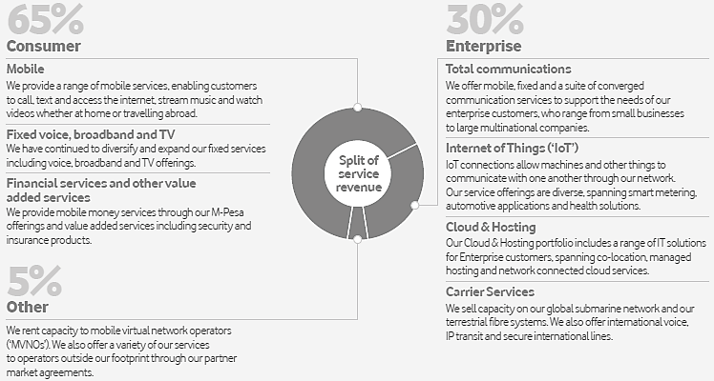

Source: Vodafone Group Plc, “Annual Report 2017,” p. 8, [http://www.vodafone.com/content/annualreport/annual_](http://www.vodafone.com/content/annualreport/annual_report17/downloads/Vodafone-full-annual-report-2017.pdf) [report17/downloads/Vodafone-full-annual-report-2017.pdf,](http://www.vodafone.com/content/annualreport/annual_report17/downloads/Vodafone-full-annual-report-2017.pdf) accessed January 2018.

**Exhibit 2** Vodafone’s Operations in 26 Countries

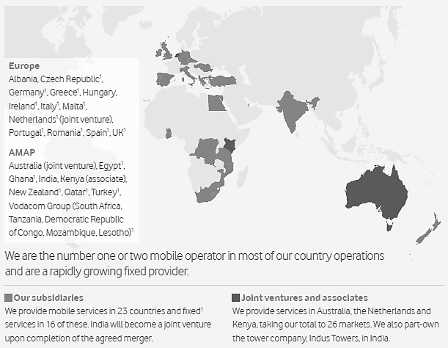

Source: Vodafone Group Plc, “Annual Report 2017,” p. 9, [http://www.vodafone.com/content/annualreport/annual_](http://www.vodafone.com/content/annualreport/annual_report17/downloads/Vodafone-full-annual-report-2017.pdf) [report17/downloads/Vodafone-full-annual-report-2017.pdf,](http://www.vodafone.com/content/annualreport/annual_report17/downloads/Vodafone-full-annual-report-2017.pdf) accessed January 2018.

1. Mobile and fixed broadband markets.

**15**

**Exhibit 3** Vodafone’s Service Revenue Breakdown 2017

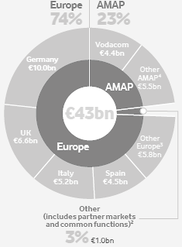

Source: Vodafone Group Plc, “Annual Report 2017,” p. 9, [http://www.vodafone.com/content/annualreport/annual_](http://www.vodafone.com/content/annualreport/annual_report17/downloads/Vodafone-full-annual-report-2017.pdf) [report17/downloads/Vodafone-full-annual-report-2017.pdf,](http://www.vodafone.com/content/annualreport/annual_report17/downloads/Vodafone-full-annual-report-2017.pdf) accessed January 2018.

1. Common functions includes revenue from services provided centrally or offered outside our operating company footprint, including some markets where we have a licensed network operation, for example offering IP-VPN services in Singapore.
2. Other Europe including eliminations.
3. Other AMAP including eliminations.

**Exhibit 4** Vodafone Group’s Main Markets and Joint Ventures in 2017

|  |  |  |  |  |  |  |
| --- | --- | --- | --- | --- | --- | --- |
|  | **Mobile customers (m)** | **Fixed customers (m)** | **Mobile revenue market share (%)** | **Fixed revenue market share (%)** | **4G coverage (%)** | **NGN**  **coverage5 (%)** |
| Germany | 30.7 | 6.3 | 33.9 | 20.6 | 90 | 65 |
| UK | 17.9 | 0.2 | 22.6 | 4.8 | 96 | 88 |
| Italy | 23.0 | 2.2 | 32.3 | 6.7 | 97 | 43 |
| Spain | 14.4 | 3.2 | ---20.06--- |  | 93 | 65 |
| Vodafone Group7 | 46.7 | <0.01 | 50.9 | 2.7 | 76 | 1 |
| India | 209.0 | 0.0 | 22.78 | 0.0 | 269 | 0 |
| VodafoneZiggo | 5.1 | 3.2 | 30.6 | 39.2 | 100 | 94 |

Source: Vodafone Group Plc, “Annual Report 2017,” p. 9, [http://www.vodafone.com/content/annualreport/annual_](http://www.vodafone.com/content/annualreport/annual_report17/downloads/Vodafone-full-annual-report-2017.pdf) [report17/downloads/Vodafone-full-annual-report-2017.pdf,](http://www.vodafone.com/content/annualreport/annual_report17/downloads/Vodafone-full-annual-report-2017.pdf) accessed January 2018.

1. Fiber or cable networks typically providing high-speed broadband over 30 Mbps.
2. Due to the converged nature of the Spanish market only total communications market shares are reported.
3. Data relates to South Africa.

8 December 2016.

9 Within Vodafone India’s 17 4G circles.

**16**

**Exhibit 5** Forecasted Global Mobile Data Traffic (’000 petabytes (1 petabyte = 1m gigabytes)

2021

2020

2019

2018

2017

2016

0

84

100

132

200

204

288

400

300

420

500

588

700

600

Source: Vodafone Group Plc, “Annual Report 2017,” p. 10, [http://www.vodafone.com/content/annualreport/annual_](http://www.vodafone.com/content/annualreport/annual_report17/downloads/Vodafone-full-annual-report-2017.pdf) [report17/downloads/Vodafone-full-annual-report-2017.pdf,](http://www.vodafone.com/content/annualreport/annual_report17/downloads/Vodafone-full-annual-report-2017.pdf) accessed January 2018.

**Exhibit 6** Fixed, Mobile, and Converged Customers 2017

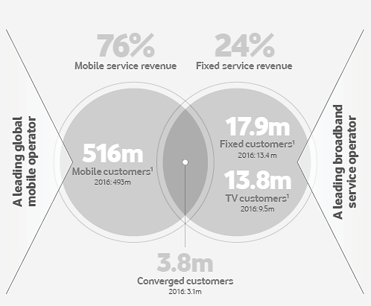

Source: Vodafone Group Plc, “Annual Report 2017,” p. 8, [http://www.vodafone.com/content/annualreport/annual_](http://www.vodafone.com/content/annualreport/annual_report17/downloads/Vodafone-full-annual-report-2017.pdf) [report17/downloads/Vodafone-full-annual-report-2017.pdf,](http://www.vodafone.com/content/annualreport/annual_report17/downloads/Vodafone-full-annual-report-2017.pdf) accessed January 2018.

Note: Includes India, joint ventures (‘JV’) and associates.

**17**

**Exhibit 7** AI Uptake Indicators

1. Share of Jobs Requiring AI Skills

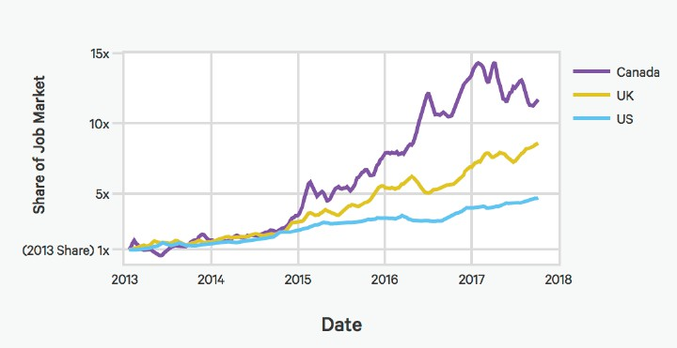

Source: Indeed.com data appearing on Artificial Intelligence Index, “2017 Annual Report,” p. 19, [https://aiindex.org/2017-](https://aiindex.org/2017-report.pdf) [report.pdf,](https://aiindex.org/2017-report.pdf) accessed February 2018.

Note: Despite the rapid growth of the Canada and UK AI job markets, Indeed.com reports they are respectively still 5% and 27% of the absolute size of the US AI job market.

1. Sentiment of Articles Referencing AI

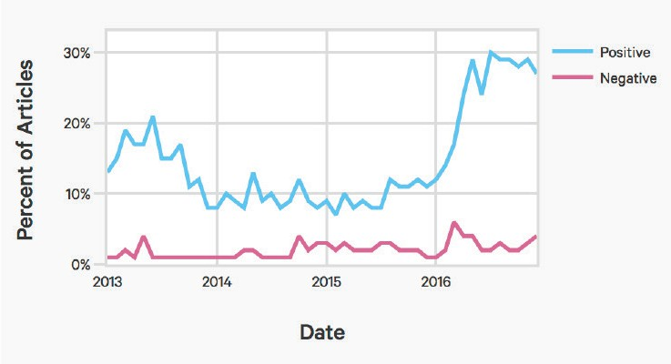

Source: TrendKite data appearing on Artificial Intelligence Index, “2017 Annual Report,” p. 25, [https://aiindex.org/2017-](https://aiindex.org/2017-report.pdf) [report.pdf,](https://aiindex.org/2017-report.pdf) accessed February 2018.

**18**

**Exhibit 8** Technology 2020 Key Deliverables by Domain (Year 2 Refresh)

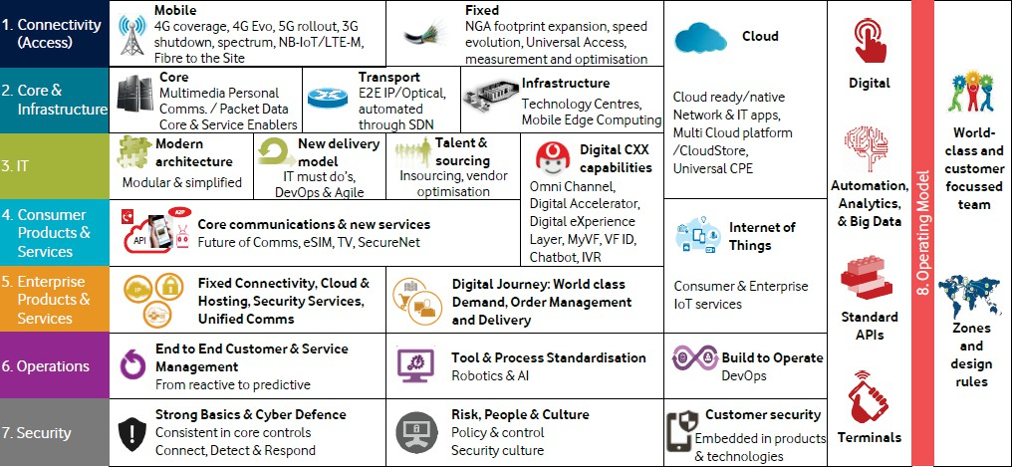

Source: Company document.

**Exhibit 9** Chatbot Development Workflow Diagram

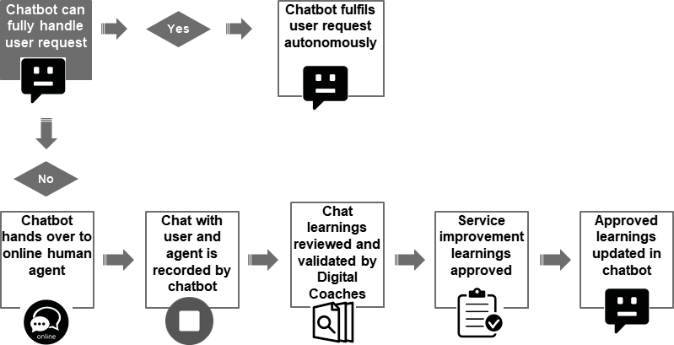

Source: Company document.

**19**

**Exhibit 10** Screenshot of Amelia Chatbot

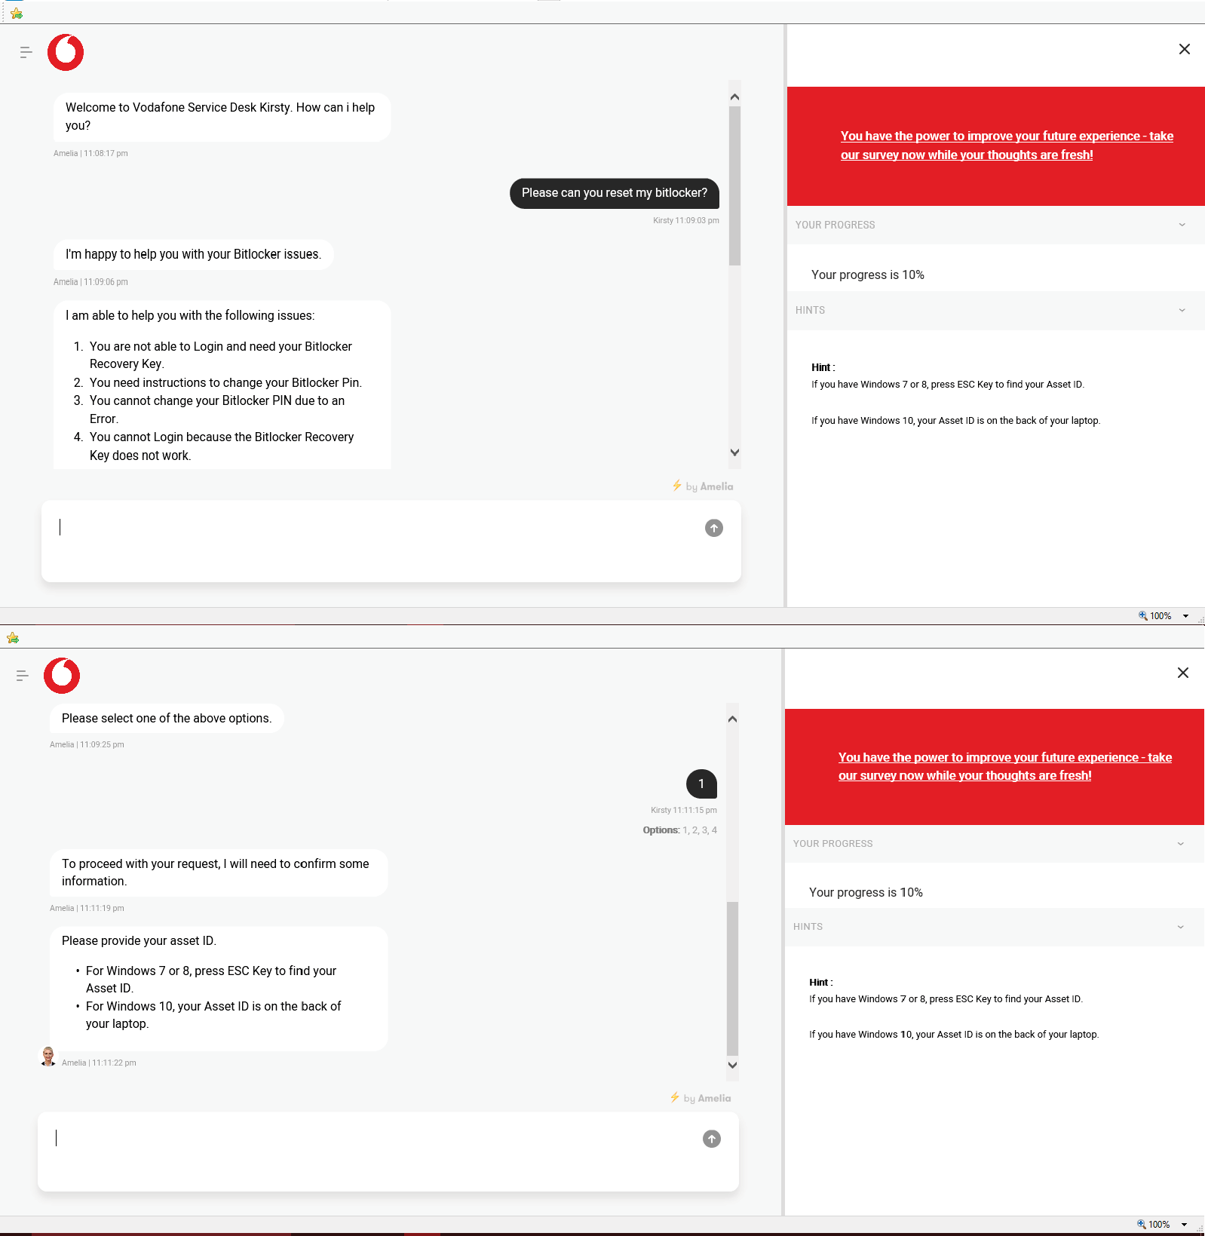

**20**

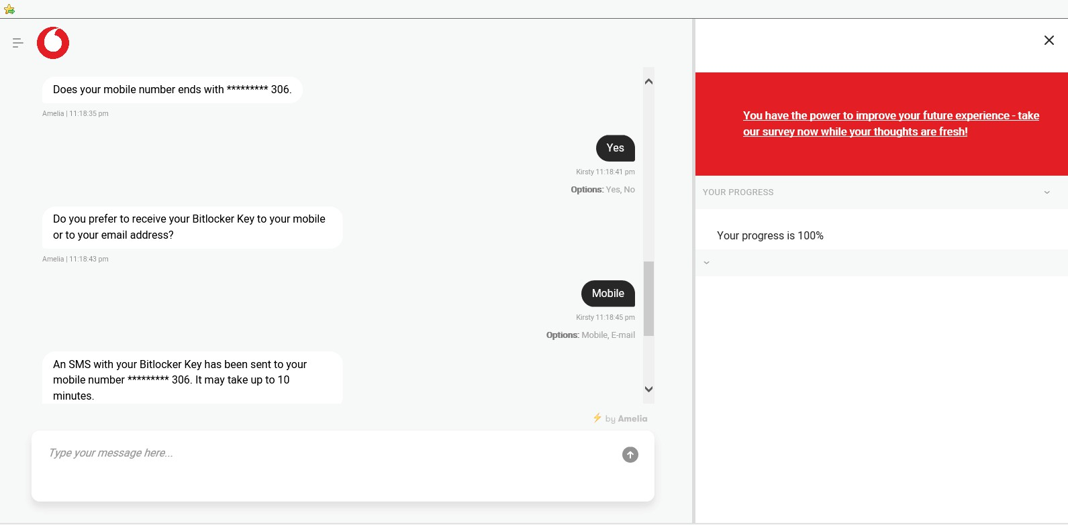

Source: Company document.

**Exhibit 11** Vodafone’s Offices

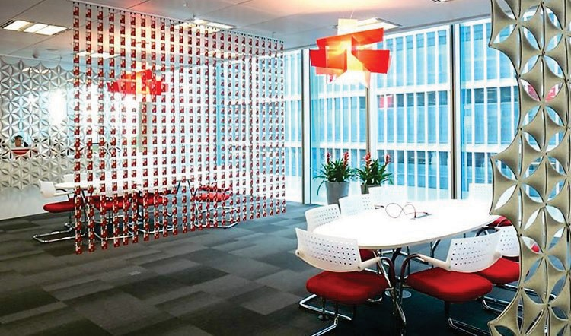

Source: Company document.

**21**

**Exhibit 12** Cognitive Engineer Profile

**Role purpose and responsibilities**

* The Cognitive Engineer is a core member of the agile teams that are implementing cognitive solutions to be fit-for-purpose, as per the functional specifications, efficient and of high quality
* The responsibility of the Cognitive Engineer is to build and implement new cognitive functionalities, including: business processes, episodic memories, knowledge ontologies & automation components

**Essence of Role – key accountabilities**

* Validate outcome of cognitive solution phase
  + Ensure the design requirements are understood when beginning with the development and implementation of a user journey
  + Clarification of functional design with the Cognitive Architects, as they are ultimately responsible for the functional designs
* Configuration of cognitive modules of Cognitive solution in line with Cognitive Technical Architect designs
  + Development of functionality in cognitive solution based on the functional design
* Connectivity of developed functionality to required systems
  + Ensure connectivity from cognitive solution to the required system using integrations via the automation framework
* Validate output and approach daily with Cognitive Project Lead or Cognitive Lead (when not in project mode), Business SME and Cognitive Architect, test until modules reach required functional behavior
  + Validate output regularly with Cognitive Project Lead and relevant Vodafone experts
  + In the daily stand-ups, priorities are confirmed with Cognitive Project Lead

**22**

|  |  |  |
| --- | --- | --- |
| **Personal specifications** |  |  |
| *Specification* | *Essential* | *Desired* |
| Graduation degree in technology | • |  |
| Working in international, distributed teams | • |  |
| Should have good analytical & troubleshooting skills | • |  |
| Should have good verbal and written communication skills | • |  |
| System analysis skills for IT troubleshooting |  | • |
| Conscientiousness and high accuracy in work | • |  |
| Understands business requirements | • |  |
| Flexible attitude and can do attitude | • |  |
| Drives improvements and process innovation | • |  |
| Familiar with cognitive technologies |  | • |
| Comfortable running testing sessions/workshops with stakeholders | • |  |
| Self-starter and taking ownership | • |  |
| Process management focused instead of number/code focused | • |  |
| **Tools/skills required** |  |  |
| *Specification* | *Essential* | *Desired* |
| Years of (similar) experience implementing business processes | 2 years | 3+ years |
| Java, Javascript, and/or Python scripting | • |  |
| Ability to create and update XML files | • |  |
| Restful API capabilities | • |  |
| Working experience with automation frameworks | • |  |
| Ability to work with regular expressions | • |  |
| Agile methodology experience |  | • |
| Business process notation (flow diagrams, symbology etc.) | • |  |
| Understanding and ability to read process flow diagrams |  | • |
| Business knowledge (organization structure, business functions, | • |  |
| Problem solving skills | • |  |
| Understanding of natural language user interaction |  | • |

Source: Company document.

**23**

# Appendix: Telecommunications Industry

The global mobile industry generated around €1.65 trillion of revenue. 52% of revenue came from traditional voice calls and messaging services. On average, a customer consumed 203 outgoing minutes per month, which had been largely stable over a number of years.17

The fixed telecommunications market included calls, broadband and TV packages, generating €0.7 trillion of revenue annually. The number of voice-only users continued to decline as customers disconnected their landlines in favor of mobile phones, however, the take-up of broadband and pay TV services offset this. According to analyst and consultancy firm Ovum, fixed broadband would be the fastest-growing market, with revenues increasing at a compound annual rate of 3.1% from 2016 to 2021, ahead of pay TV at 2.5% and mobile at 1.9% In broadband markets, an increasing proportion of customers were upgrading from copper-based ADSL with speeds up to 24 Mbps to high-speed fiber and cable with speeds up to 1,000 Mbps. According to Vodafone, Gigabit networks direct to homes and businesses would form the bedrock of modern digital communications infrastructure.18

The telecommunications industry had transformed significantly in the last 30 years. In the 1990s, mobile phones were mostly used for calls on 2G networks, and basic picture messages could be sent at very low speeds of 50–200 Kbps, while in 2017 users could enjoy 4G speeds of up to 800 Mbps for rapid video downloads, with 1 Gbps speeds already demonstrated. This network technology innovation had been accompanied by the growing demand for smartphones, which were now used by 63% of Vodafone’s European customers. Fixed network development had been equally rapid. In the 1990s, most fixed connections were for landline calls, today the greatest use was broadband internet usage. Average download speeds had progressed rapidly from around 8–16 Mbps using copper-based technology in 2007 to 1 Gbps using cable or fiber today. These developments brought significant opportunities to drive further revenue from increased data usage, but also required investment to keep up with technology.19

**24**

# Endnotes

1. Wood, Nick, “Vodafone ups guidance on solid 1H earnings growth,” *Total Telecom Plus*, November 14, 2017, via Factiva, accessed January 2018.
2. “Half Year 2018 Vodafone Group PLC Earnings Presentation – Final,” *CQ FD Disclosure*, November 14, 2017, via Factiva, accessed January 2018.
3. “Vodafone Group Plc”, via Capital IQ, accessed January 2018.
4. Vodafone Group Plc, “Annual Report 2017,” [http://www.vodafone.com/content/annualreport/annual_report17/](http://www.vodafone.com/content/annualreport/annual_report17/downloads/Vodafone-full-annual-report-2017.pdf) [downloads/Vodafone-full-annual-report-2017.pdf,](http://www.vodafone.com/content/annualreport/annual_report17/downloads/Vodafone-full-annual-report-2017.pdf) accessed January 2018.
5. Ibid.
6. Ibid.
7. Ibid.
8. Ibid.
9. Vodafone Group Plc, “Vodafone Shared Services,” [http://www.vodafone.com/content/index/what/vodafone-shared-](http://www.vodafone.com/content/index/what/vodafone-shared-services.html) [services.html,](http://www.vodafone.com/content/index/what/vodafone-shared-services.html) accessed January 2018.
10. Shaw, Gina, “How AI-Powered Enterprise Chatbot Platforms Are Transforming the Future of Work,” *Chatbots Magazine,* November 22, 2017, [https://chatbotsmagazine.com/how-ai-powered-enterprise-chatbot-platforms-are-transforming-the-](https://chatbotsmagazine.com/how-ai-powered-enterprise-chatbot-platforms-are-transforming-the-future-of-work-dceed4cdfe50) [future-of-work-dceed4cdfe50,](https://chatbotsmagazine.com/how-ai-powered-enterprise-chatbot-platforms-are-transforming-the-future-of-work-dceed4cdfe50) accessed January 2018
11. Tan, Emily, “Vodafone to ramp up customer service with upgraded chatbot, voice ID and Alexa skill,” *Campaign*, July 19, 2017, [https://www.campaignlive.co.uk/article/vodafone-ramp-customer-service-upgraded-chatbot-voice-id-alexa-](https://www.campaignlive.co.uk/article/vodafone-ramp-customer-service-upgraded-chatbot-voice-id-alexa-skill/1439843) [skill/1439843,](https://www.campaignlive.co.uk/article/vodafone-ramp-customer-service-upgraded-chatbot-voice-id-alexa-skill/1439843) accessed January 2018.
12. “Vodafone puts focus on AI and voice in renewed customer service push,” *Marketing Week,* July 19, 2017, [https://www.marketingweek.com/2017/07/19/vodafone-ai-voice-customer-service-push/,](https://www.marketingweek.com/2017/07/19/vodafone-ai-voice-customer-service-push/) accessed January 2018.
13. Wilkinson-Jones, Phil, “Vodafone chatbot will give customers 'instant answers' but won't replace humans just yet,” *Cable.co.uk*, April 19, 2017, [https://www.cable.co.uk/news/vodafone-chatbot-will-give-customers-instant-answers-but-wont-](https://www.cable.co.uk/news/vodafone-chatbot-will-give-customers-instant-answers-but-wont-replace-humans-just-yet-700001789/) [replace-humans-just-yet-700001789/,](https://www.cable.co.uk/news/vodafone-chatbot-will-give-customers-instant-answers-but-wont-replace-humans-just-yet-700001789/) accessed January 2018.
14. Tan, Emily, “Vodafone to ramp up customer service with upgraded chatbot, voice ID and Alexa skill,” *Campaign*, July 19, 2017, [https://www.campaignlive.co.uk/article/vodafone-ramp-customer-service-upgraded-chatbot-voice-id-alexa-](https://www.campaignlive.co.uk/article/vodafone-ramp-customer-service-upgraded-chatbot-voice-id-alexa-skill/1439843) [skill/1439843,](https://www.campaignlive.co.uk/article/vodafone-ramp-customer-service-upgraded-chatbot-voice-id-alexa-skill/1439843) accessed January 2018.
15. Chandler, Simon, “The AI Chatbot Will Hire You Now,” *Wired.Com*, September 13, 2017, [https://www.wired.com/story/the-ai-chatbot-will-hire-you-now/,](https://www.wired.com/story/the-ai-chatbot-will-hire-you-now/) accessed January 2018.
16. Johansson, Anna, “AI Matches Applicants with the Right Jobs Based On Their Face,” *Psfk.Com*, August 30, 2017, [https://www.psfk.com/2017/08/ai-matches-applicants-with-the-right-jobs-based-on-their-face.html,](https://www.psfk.com/2017/08/ai-matches-applicants-with-the-right-jobs-based-on-their-face.html) accessed January 2018.
17. Vodafone Group Plc, “Annual Report 2017,” [http://www.vodafone.com/content/annualreport/annual_report17/](http://www.vodafone.com/content/annualreport/annual_report17/downloads/Vodafone-full-annual-report-2017.pdf) [downloads/Vodafone-full-annual-report-2017.pdf,](http://www.vodafone.com/content/annualreport/annual_report17/downloads/Vodafone-full-annual-report-2017.pdf) accessed January 2018.
18. Ibid.
19. Ibid.

**25**